Docker – 01

To execute the task Launched t2.large instance.

1) Install docker on ec2.

Update and install Docker:
sudo yum update -y
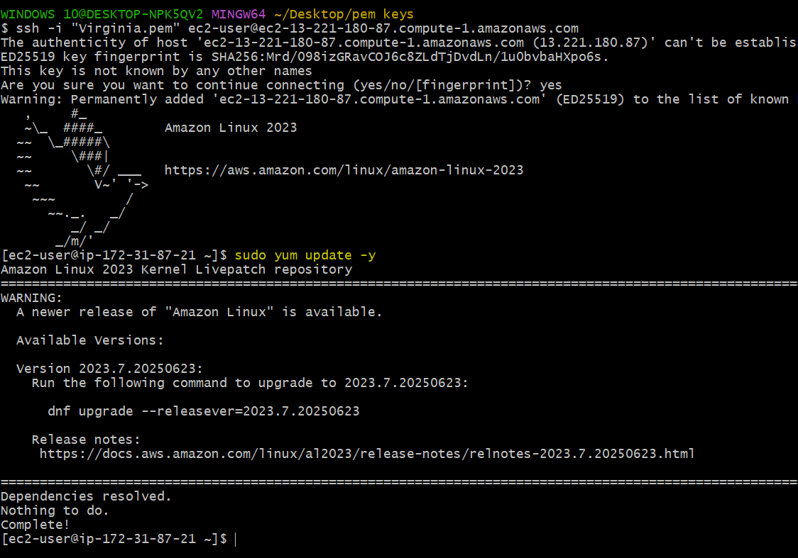

sudo yum install docker -y
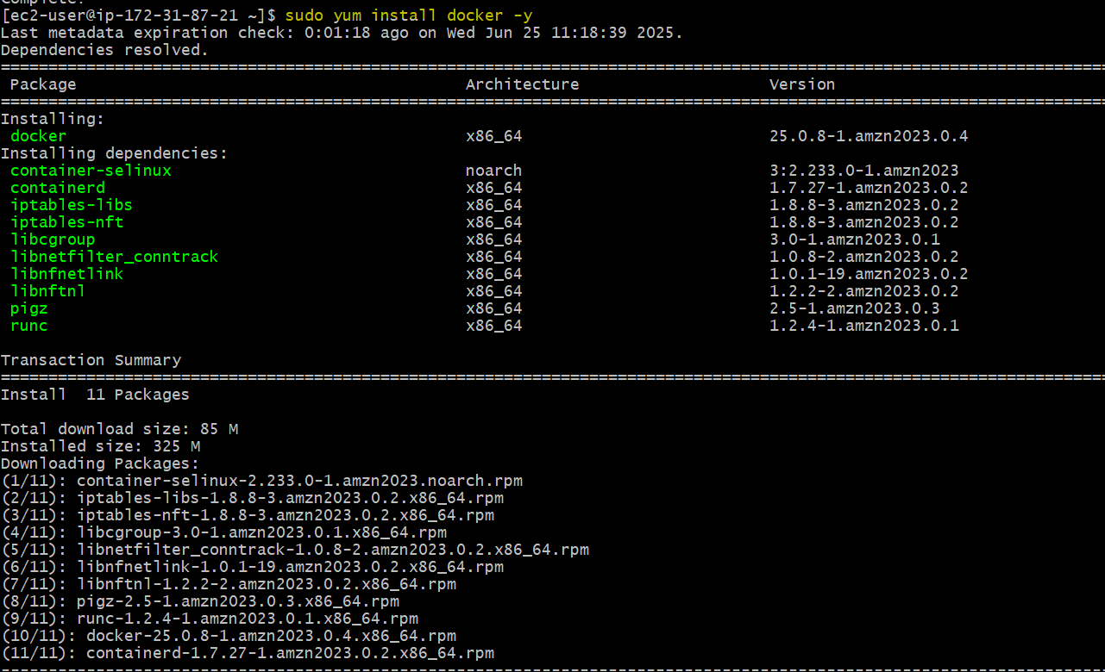

Start and enable Docker:
sudo systemctl start docker
sudo systemctl enable docker
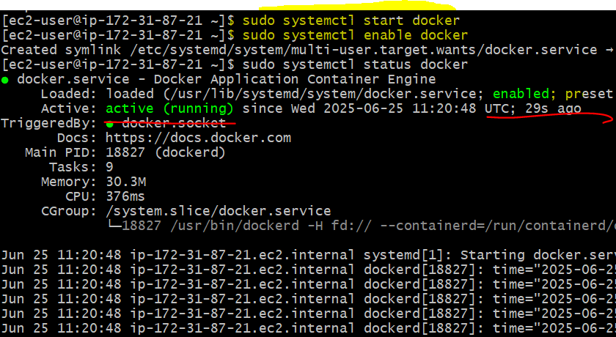

2) Pull 5 docker images. (nginx, apache tomcat, ubuntu, jenkins, sonarqube)

Pull Docker Images

docker pull nginx
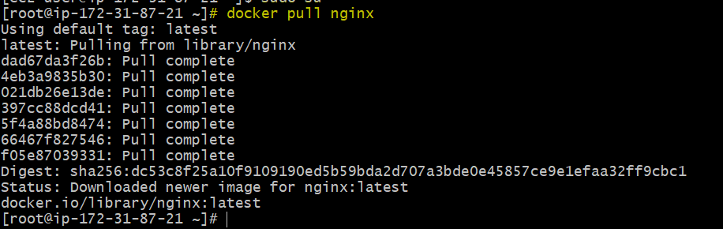

docker pull tomcat
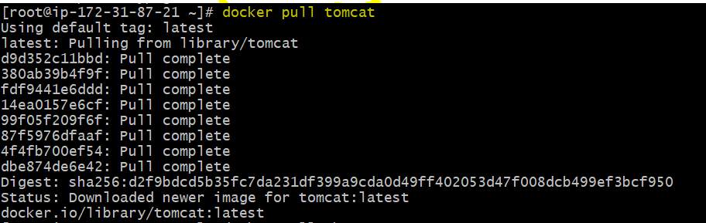

docker pull ubuntu
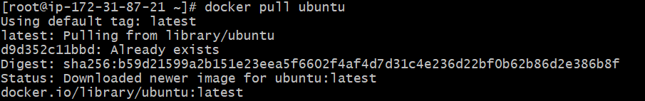

docker pull jenkins/Jenkins
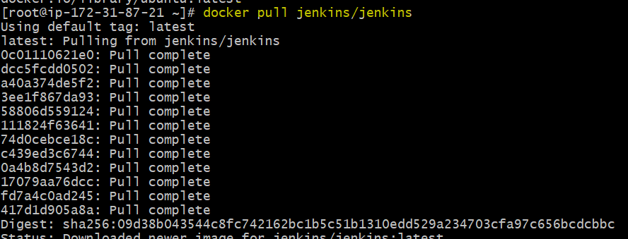

docker pull sonarqube
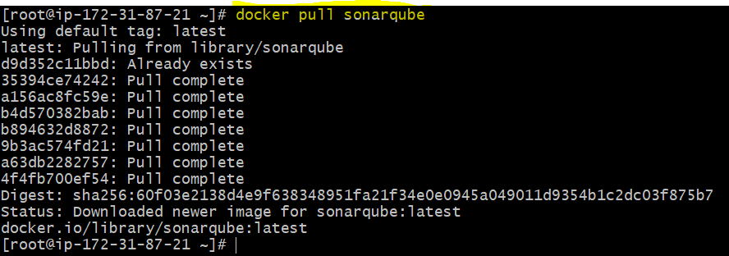

Docker images – To check available images.
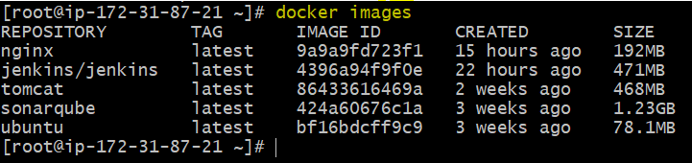

3) Run nginx container and expose on port 81.

Run Nginx Container on Port 81

docker run -d --name my-nginx -p 81:80 nginx
- -d: Run in detached mode.
- --name my-nginx: Assign a name to the container.
- -p 81:80: Map host port 81 to container port 80.
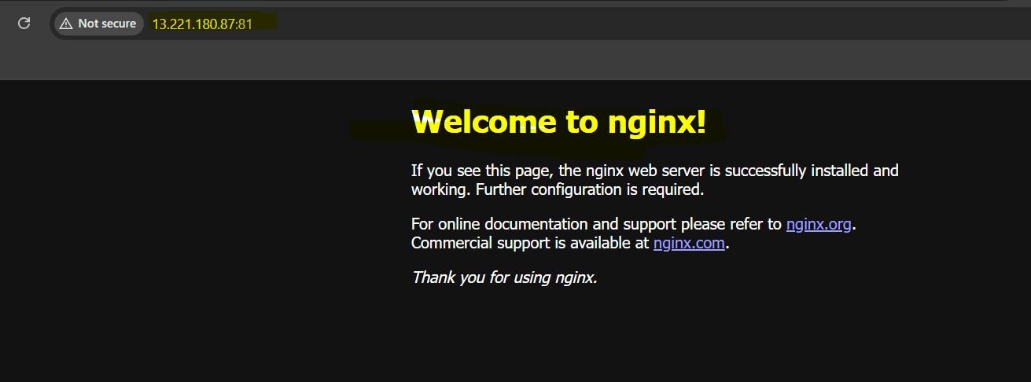

4) Delete the apache tomcat image from local.

Delete Apache Tomcat Image

docker rmi tomcat
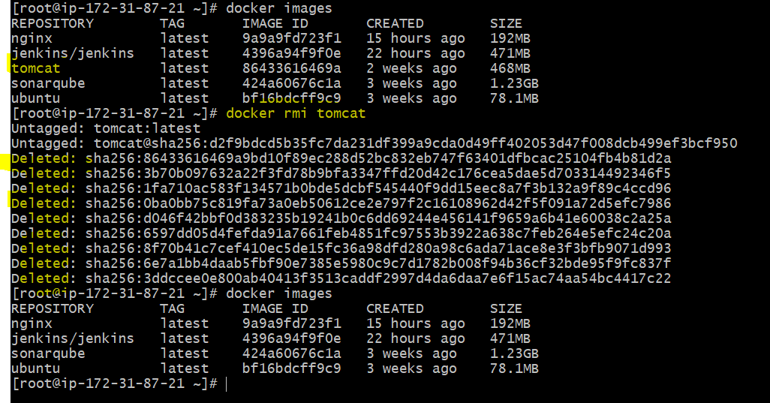

5) Inspect the jenkins image,sonarqube image.

Inspect Jenkins and SonarQube Images

docker inspect jenkins/Jenkins
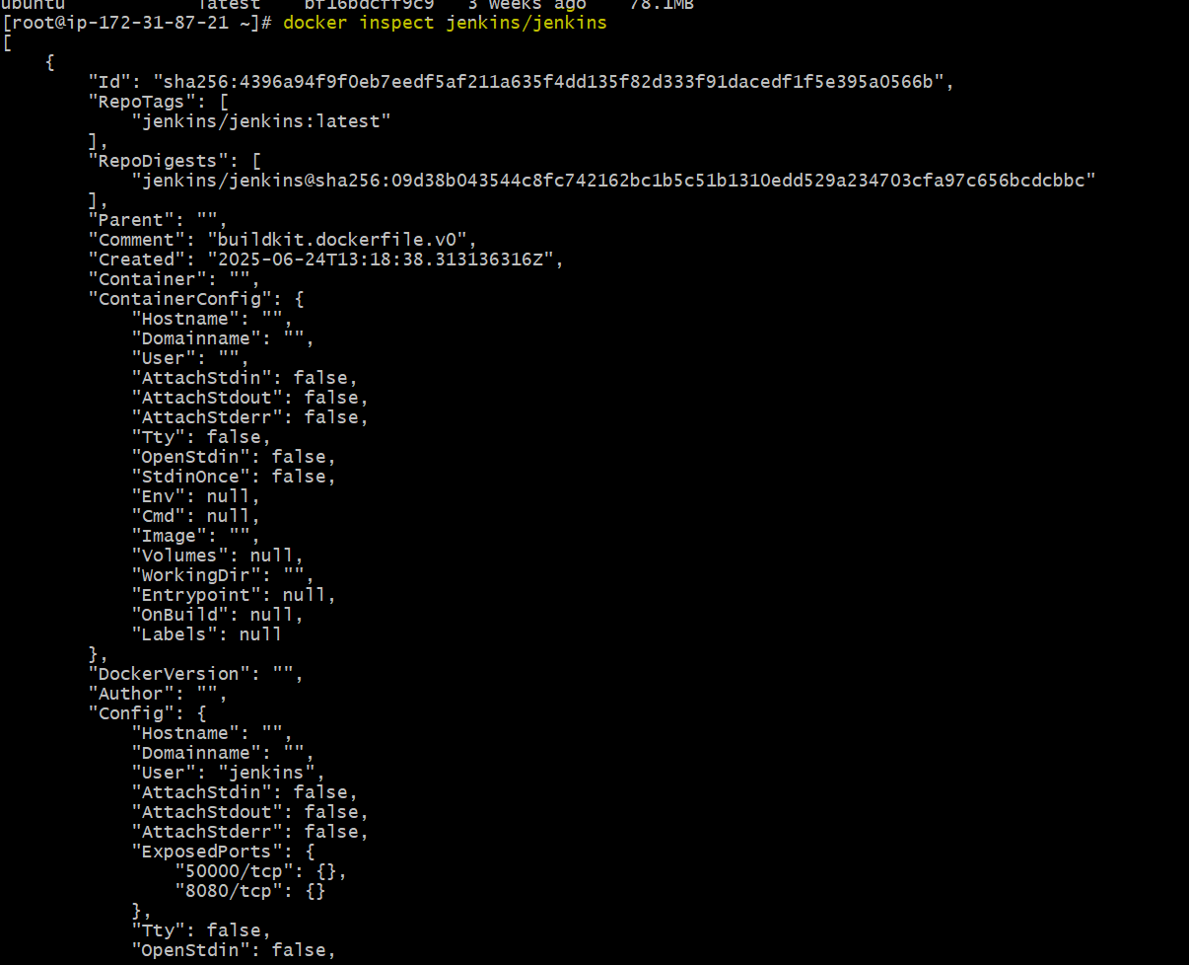
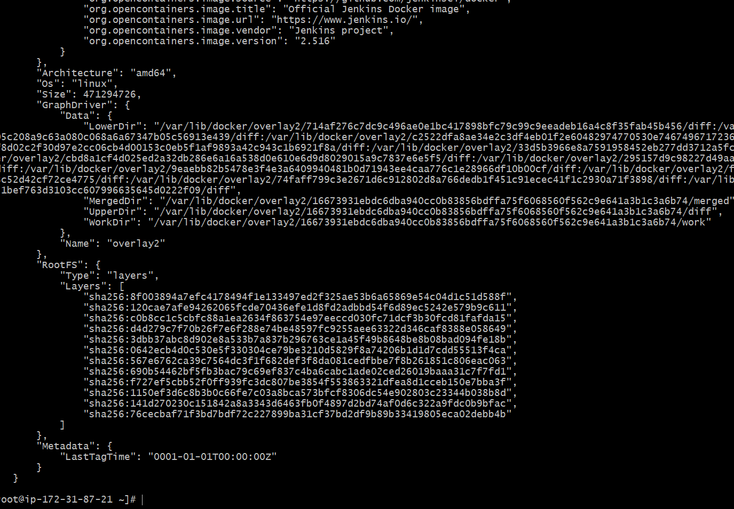

docker inspect sonarqube
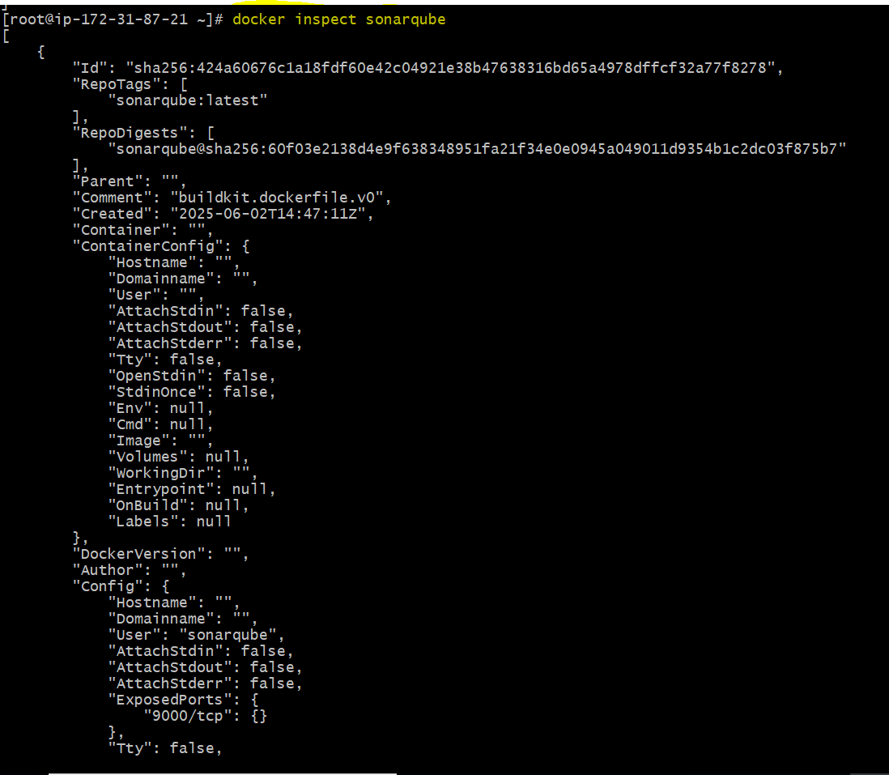
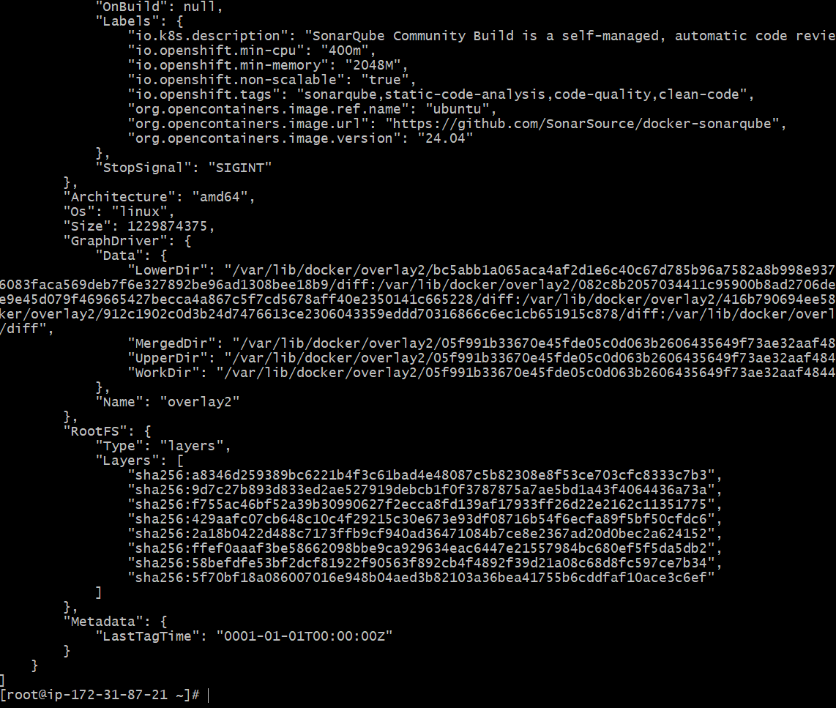

6) Run jenkins contianer and run one sample job.

Run Jenkins Container and Execute Sample Job

Run Jenkins:
docker run -d --name my-jenkins -p 8080:8080 -p 50000:50000 jenkins/Jenkins
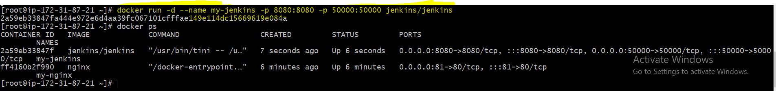
- Access Jenkins on: http://<your-ec2-public-ip>:8080
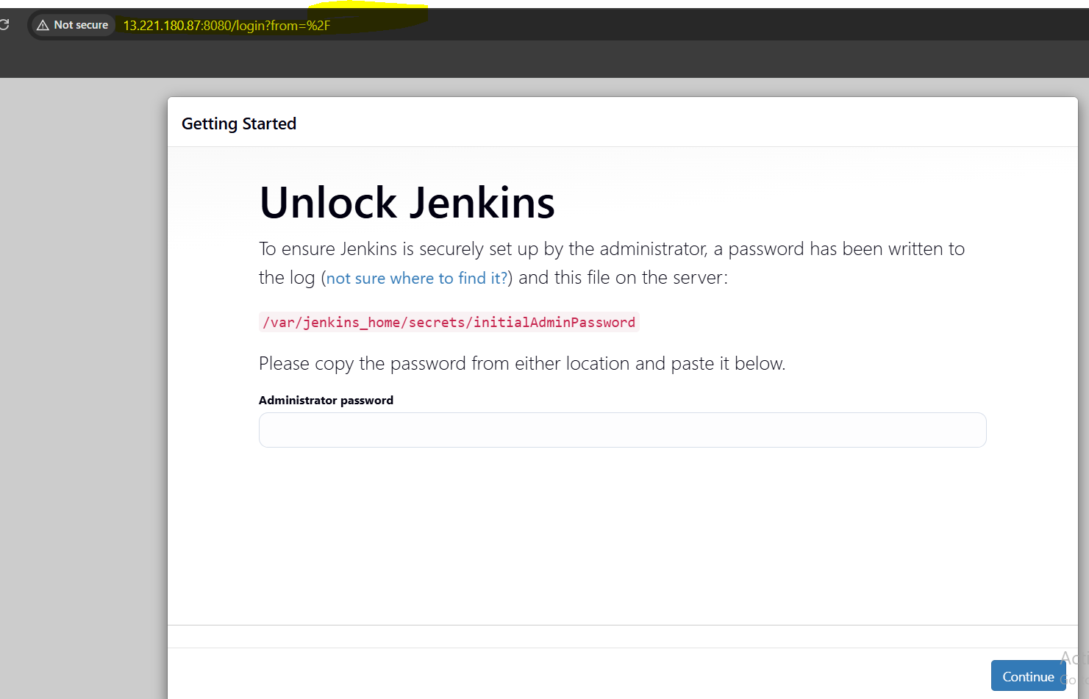

Initial Jenkins Setup:
- Get the admin password:
docker exec my-jenkins cat /var/jenkins_home/secrets/initialAdminPassword

- Complete the setup in the Jenkins UI.
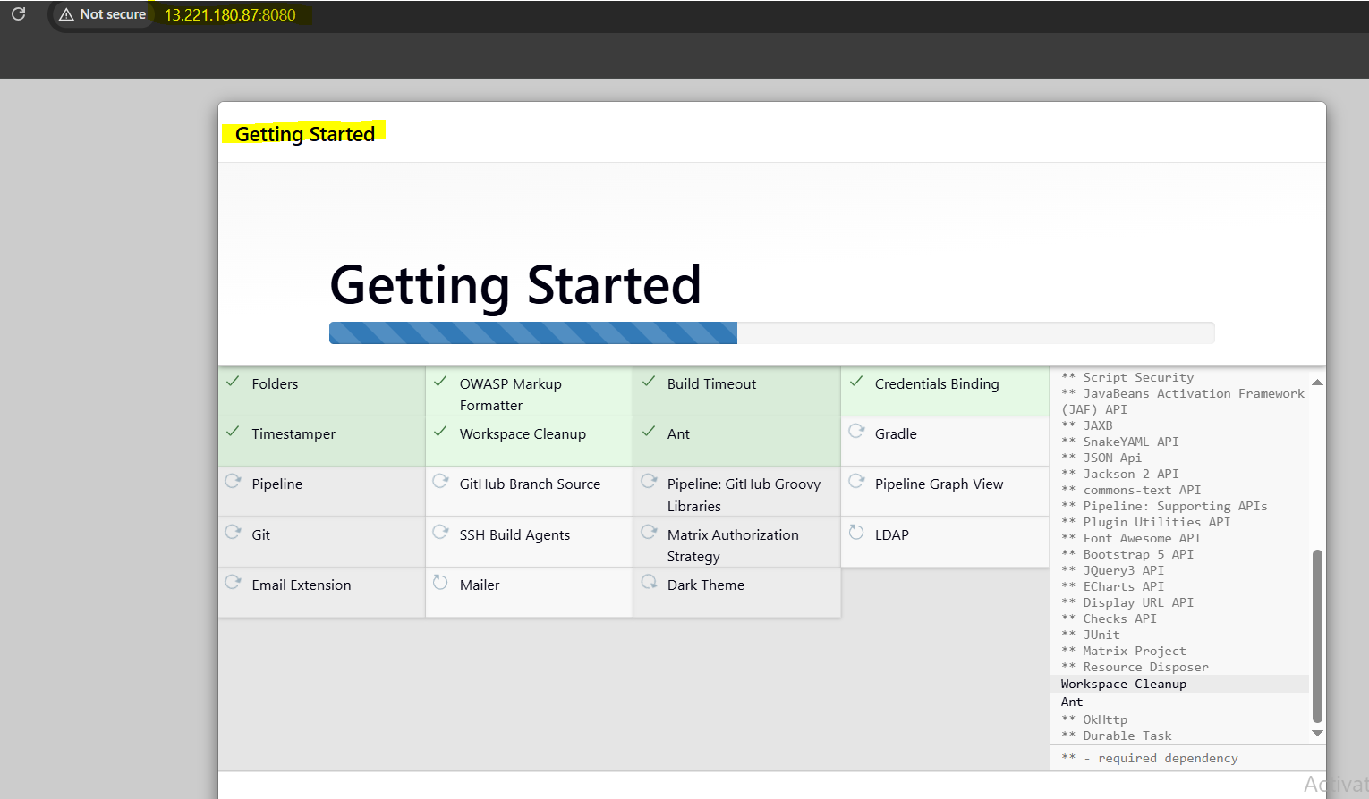
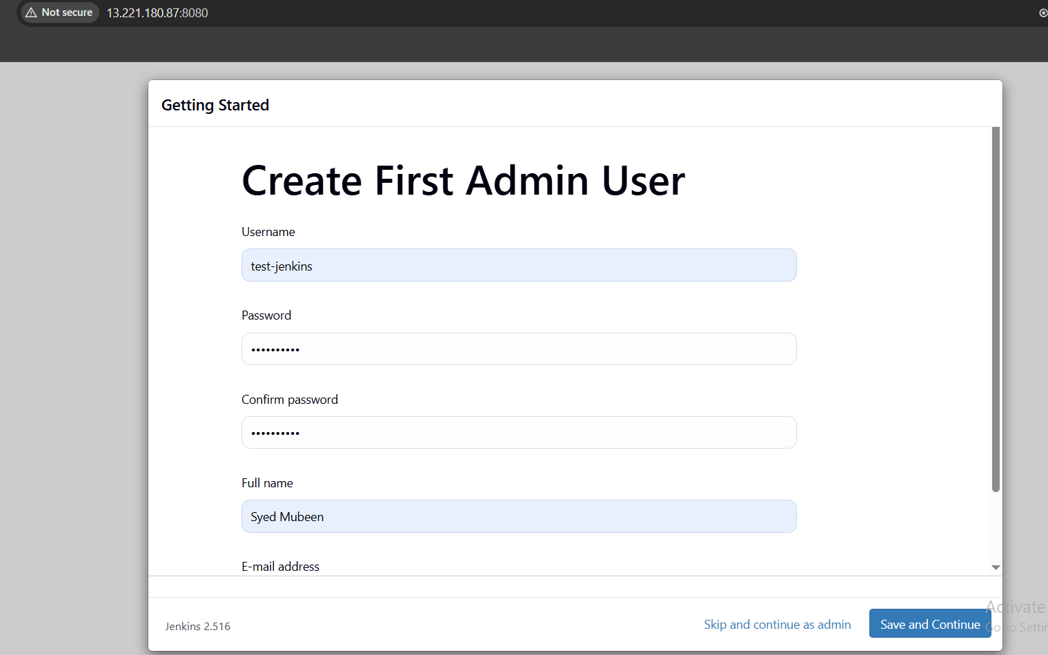

Create a Sample Job:
Go to Jenkins Dashboard → New Item.
Enter job name, select Freestyle project, click OK.
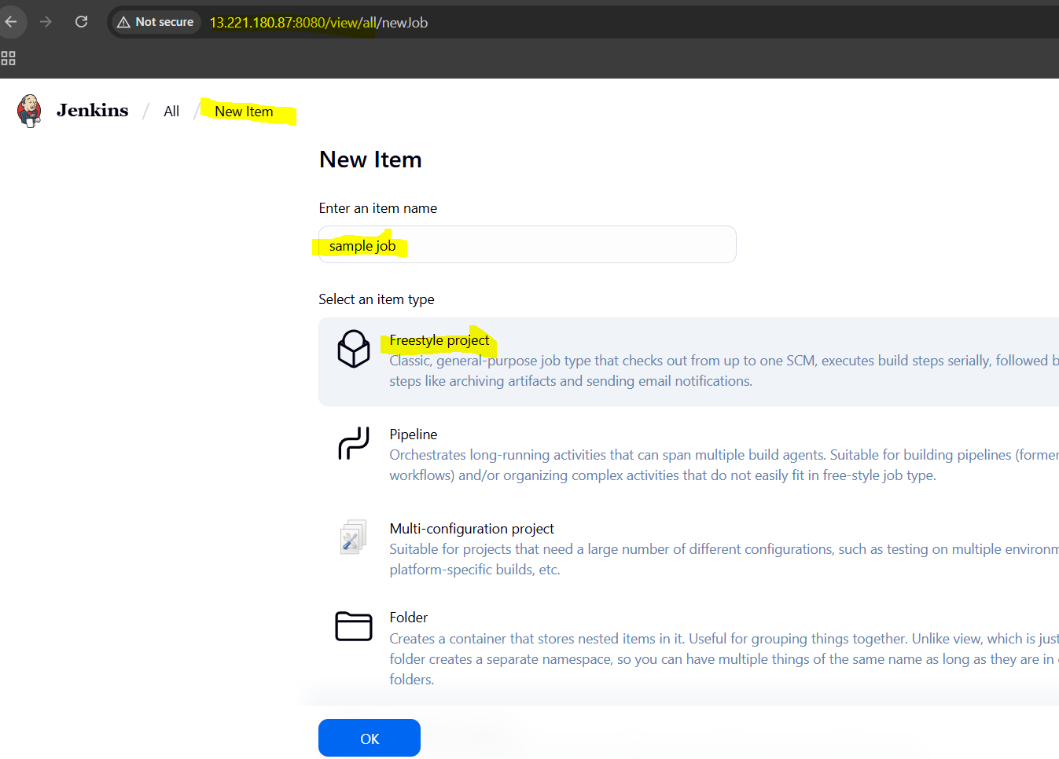

In Build section, click Add build step → Execute shell.
Enter:
echo "Hello from Jenkins sample Job from docker!"
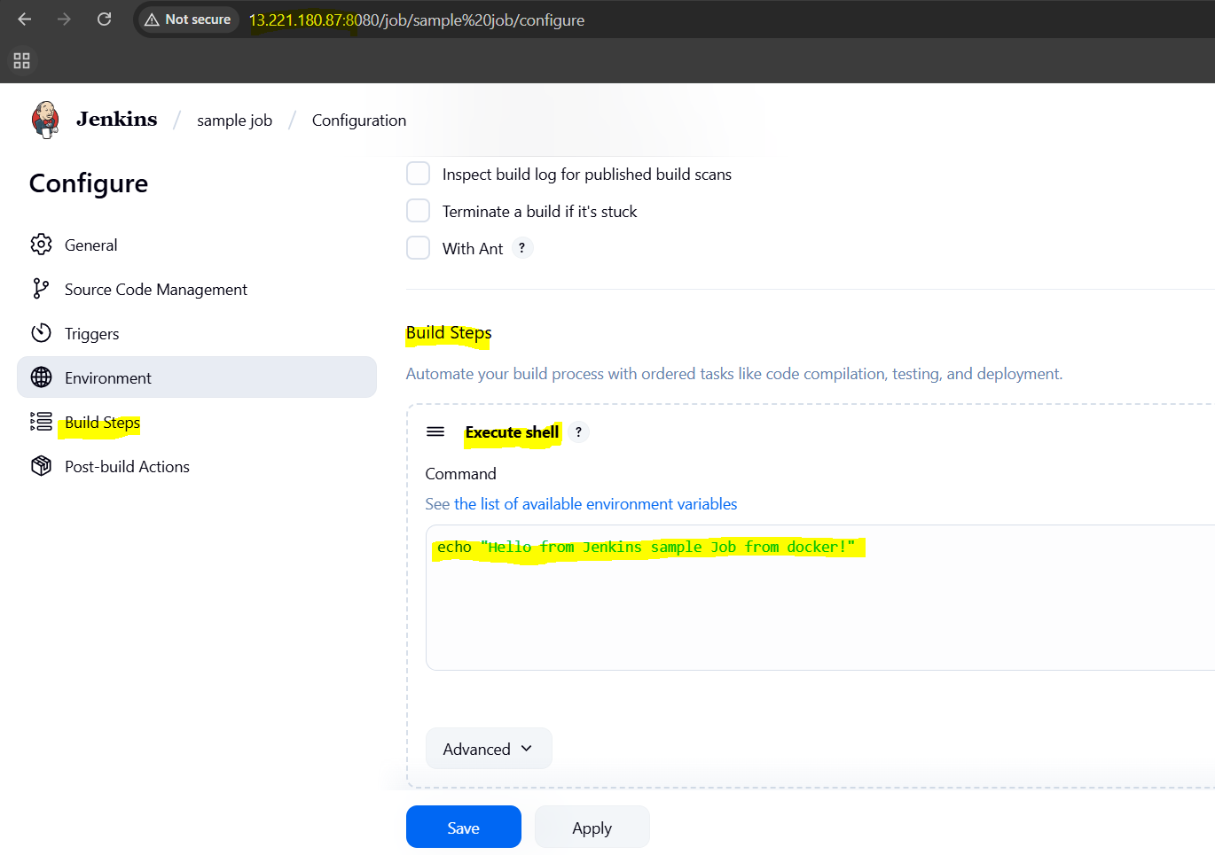

Save and Build Now.
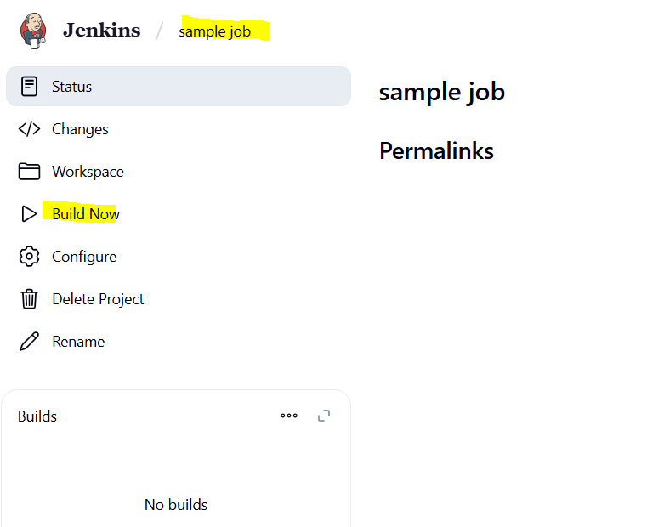

Console Output:
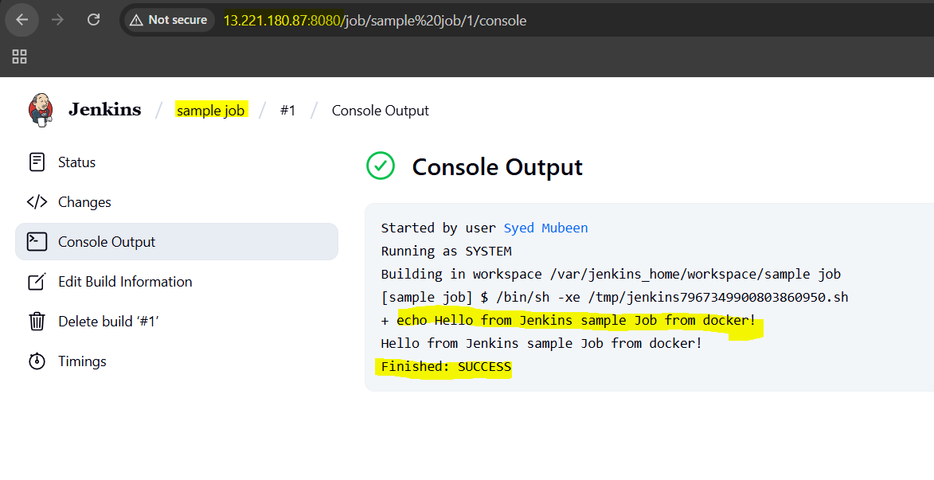

Docker:
Docker is a platform that uses containerization to build, package, and run applications in isolated environments called containers.
It simplifies deployment by ensuring the application works uniformly across different environments.
Docker uses lightweight containers that are faster and more efficient than traditional virtual machines.

Virtualization:
Virtualization uses a hypervisor to run multiple virtual machines (VMs) on a single physical server.
Each VM includes its own operating system, which makes them heavy and resource-intensive.
It allows complete OS-level isolation but with more overhead compared to containers.

Containerization:
Containerization packages applications with their dependencies into lightweight containers that share the host OS kernel.
Containers are faster to start, use fewer resources, and are easily portable across environments.
It isolates applications efficiently without needing full operating systems like VMs.

Difference Between Virtualization and Containerization (Summary)
Feature | Virtualization | Containerization
Isolation | Full OS-level | Application-level
Startup Time | Minutes | Seconds
Resource Usage | Heavy (includes OS) | Lightweight (shares OS kernel)
Portability | Less portable (OS-specific) | Highly portable
Performance | More overhead | Near-native performance

Docker Commands (One-line Explanation)
Command | Description
docker --version | Displays the installed Docker version.
docker help | Shows the list of Docker commands and usage.
docker pull <image> | Downloads the specified image from Docker Hub.
docker images | Lists all Docker images on the local system.
docker rmi <image> | Removes the specified Docker image.
docker run <options> <image> | Runs a new container from an image.
docker ps | Lists running containers.
docker ps -a | Lists all containers (running and stopped).
docker logs <container> | Displays logs from the specified container.
-it | Runs container interactively with a terminal.
-itd | Runs container interactively in detached mode.
-p <host-port>:<container-port> | Maps host port to container port.
docker start <container> | Starts an existing stopped container.
docker stop <container> | Stops a running container.

THE-END

